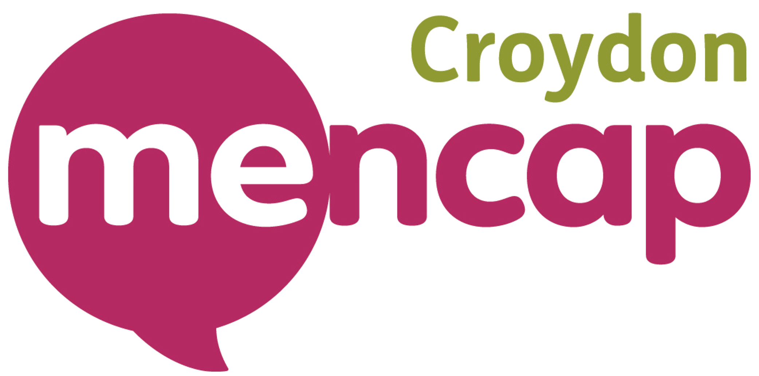

Job Title: Community Energy Advice Lead

Location: Community based (with some office/home working)
Hours: Part time 22.5 hours per week, flexible

Salary: £17 per hour (£19,890 part time. Full time equivalent is £33,150)

Contract: fixed term to March 2028 – then subject to further funding

Why Work for Croydon Mencap

Joining Croydon Mencap means being part of a supportive, flexible, and values driven Charity. As a Community Energy Advisor Lead, you will enjoy:

Flexible working culture – balance your work with personal commitments
Employee Assistance Programme (EAP) – free counselling for you and your family, plus financial and wellbeing advice
Blue Light Card membership – Gives access to 15,000+ discounts on shopping, food, travel, days out.
Enhanced sick pay – after your first year, receive up to 9 days full pay.
Pension Scheme contribution – 3% paid into your pension
Access to internal staff gatherings and wellbeing initiatives
Professional support and development – training opportunities to grow your skills in community energy advice, data management, and community engagement.

Our Commitment to Inclusion

At Croydon Mencap, we are proud to be a ‘Disability Confident’ Accredited Employer and a truly inclusive workplace. We value the diversity of our staff, residents, and communities, and actively celebrate differences in:

Racial and ethnic diversity – creating a workplace where people of all backgrounds feel welcome and valued
Neurodiversity – supporting people with different learning styles and neurological profiles
Disability – committed to accessibility, reasonable adjustments, and equal opportunities
LGBTQ+ identities – fostering a safe, supportive, and inclusive environment
Gender and life stage diversity – including menopause, caring responsibilities, and flexible working needs
All other aspects of diversity, recognising that everyone’s experience, background, and perspective matters

We are committed to creating a workplace where everyone can thrive, contribute, and feel valued.

Important requirements:

This role requires an Enhanced DBS check
References will be requested prior to appointment

Job Overview
The Community Energy Advisor Lead will deliver a community-based energy advice service to Croydon residents with a learning disability and their support network, supporting them to access practical energy efficiency measures, reduce fuel costs, and connect with relevant support services.
The role combines frontline delivery, coordination, and data management, ensuring that the service meets agreed targets and reporting requirements set by SGN (the funder).
The postholder will be responsible for:
- Delivering accessible, person-centred energy advice through outreach and community settings
- Managing a caseload of residents requiring support
- Accurately recording, monitoring, and reporting on all activity and outcomes
- Ensuring delivery aligns with funding requirements, including the number of residents supported and the types of interventions provided.
This is a hands-on delivery role with accountability for performance and data quality.

Key Performance Summary: Community Energy Advisor Lead
This role delivers a high-impact, community-based energy advice service, you are required to support 560 residents per year who have a learning disability and or their family / support network each year to stay safe, reduce energy costs, and access wider support.
You will combine practical advice, meaningful engagement, and strong data capture to ensure every interaction contributes to measurable outcomes.

Your Annual Impact
You will:
- Support and energy triage 563 residents per year (46 residents per month) providing energy advice, safety information, and practical support
Of those triaged above:
- Provide 15 carbon monoxide (CO) alarms to improve household safety
- Support at least 50 residents to join the Priority Services Register, improving access to essential support
- Provide 5 residents with billing and meter reading support
- Deliver wellbeing-focused energy engagement to 100 residents, including community events that combine energy advice with wider wellbeing support
To ensure you can reach the residents above and the numbers, you will be delivering from community bases where lots of residents visit, you will organise and deliver occasional events to capture large groups of people, you may visit other organisations to increase your reach and recruit volunteers to support you with your activities.

Driving Real Change
Your work will go beyond advice by creating tangible outcomes. Each year 10 people from your triage list you will:
- Develop in-depth case studies demonstrating meaningful (substantial measures)
- Support residents to access wider services such as debt advice, housing, and social care
- Capture behaviour changes and improved outcomes across all interactions, this could include survey results

Financial & Practical Outcomes
From the 560 residents triaged, you will help residents maximise income and reduce financial pressure by at least:
- 70 residents supported with referrals to welfare benefits advice
- 20 supported with referrals to debt management advice
- Including 20 supported with debt write-off
- 10 supported to access energy funding
- 5 supported with grant applications
- 5 supported with tariff switching
- 10 supported to access water social tariffs
- 60 supported with emergency food vouchers/food bank referrals

Safety, Awareness & Referrals
You will ensure residents are safer and better informed by delivering:
- 20 referrals to Fire & Rescue Safe and Well visits
- 10 referrals provided locking cooker valves
- 40 residents supported with scams awareness information

Building Community Capacity
You will also strengthen the wider community by:
- Supporting 5 third party frontline workers to complete think CO safety training
- Supporting at least 1 organisation or group to access energy efficiency training
- Building relationships with local groups, faith organisations, and partners to extend reach and impact

What Success Looks Like
Success in this role means:
- Consistently meeting targets
- Delivering high-quality, person-centred support
- Capturing clear, accurate data and evidence of impact
- Creating a service that is visible, trusted, and embedded in the community
- Working well in partnership with others including the Local Voluntary Partnership and Community Hubs, Faith groups, Charities and community groups.
Qualifications:
- Experience in community support work in Croydon or related fields.
- Understanding of energy efficiency programs and resources, although full training provided.
- Strong communication and interpersonal skills, with a genuine interest in helping individuals with LD.
- Ability to work independently and communicate well with others
- ability to be organised, to track and record data
- Flexible and adaptable approach to meet the needs of the community.

You will receive full training:
- Level 2 – Fuel debt advice in the community:
- Think Co awareness training

Application Process:
Interested candidates should submit an online application for at: Applications will be accepted until 12pm Wednesday April 22nd
Interviews Friday 24th April.

This job description is tailored to reflect the responsibilities and expectations of a Community Energy Advice Lead community role. If you need adjustments or additional information, please let us know.

